Strategic Problem Statement

Business Context
Scenario. City Hotel Lisbon sells perishable room inventory ahead of arrival, largely through travel agents and operators. Until the guest arrives, revenue is only expected, not secured.
Strategic issue. Revenue-management research identifies booking cancellations as a core source of demand uncertainty: they limit the accuracy of forecasts, and the usual responses, rigid cancellation policies and overbooking, can themselves damage revenue and reputation (Antonio et al., 2017). For City Hotel Lisbon, this means expected revenue and room plans cannot be fully relied on, and blanket policies are an imperfect fix. Cancellation is therefore a strategic revenue-risk problem, not just an operational event. Its scale is quantified in Section 1.2.
Cross-domain impact. One cancellation touches several domains at once, and we assume (to be validated with hotel stakeholders) that each is managed separately today, so no single view supports a joint decision.
Domain | Assumed current state (to validate) | Gap the project addresses
Distribution / Marketing | Measured: cancellation risk differs sharply by channel and segment (17.3%–68.9%). Assumed: it is not yet used in booking management. | Channel and segment risk guides booking management.
Customer Experience | Assumed: pre-arrival confirmations are manual and not prioritised by risk (simulated in the CX table as about 30% of bookings contacted). | Routine confirmation for all bookings; enhanced, prioritised contact for high-risk bookings.
Finance | Assumed: commission, handling cost and revenue at risk are not linked (the extract has no cost data). | Net value of actions accounts for cost.
Operations | Assumed: resale of freed rooms is not guided by cancellation risk. Simulated resale covers 50.7% of cancelled room-nights (no-shows excluded): a scenario output, not an observed rate. | Resale and capacity decisions are guided by cancellation risk.
Note: entries marked “Assumed” are scenario assumptions for this case, not findings from the dataset; they must be validated with hotel stakeholders. Entries marked “Measured” come from the booking extract.
Transformation opportunity. Integrating booking, customer, cost and inventory data into one decision-support system can shift the hotel from reactive handling to risk-based, proactive booking management, optimizing revenue and room capacity.

Business Pain Points
Baseline: City Hotel Lisbon, 79,330 bookings, July 2015 – August 2017 (Antonio, Almeida & Nunes, 2019).
Pain point | Supporting data | Why it matters
Limited visibility into cancellation risk | 41.7% of bookings (about 33,000) were cancelled or no-show. 12.0% of cancellations (status Canceled; 14.5% if no-shows count as 0-day notice) occur within 7 days of arrival. | Late cancellations leave the least time to resell the room. Early warning is the only way to act before that window closes.
Inefficient allocation of follow-up resources | Travel agents and operators handle 87% of bookings. Cancellation rate ranges from 17.3% (Direct) to 68.9% (Groups). Assumed (to validate): contact with at-risk guests is not systematic. | Risk varies widely across segments, so uniform follow-up wastes effort on safe bookings and misses risky ones. Hospitality churn research on repeat-customer retention supports targeting high-risk customers rather than contacting everyone (van Leeuwen et al., 2025); its transfer to booking cancellation is an assumption to test in a pilot.
Limited ability to optimize revenue and room capacity | €10.9M of €25.3M gross booked room revenue (about 43%) is tied to cancelled bookings. Assumed: freed rooms are not resold based on risk, and commission and handling cost are not linked to risk. | The hotel cannot tell which bookings to act on, or how to adjust follow-up, pricing, capacity allocation and resale so that revenue and occupancy are optimized net of intervention cost. Revenue-management studies show that cancellation-aware pricing, allocation and overbooking decisions can raise profit in simulation (Dong & Ling, 2015; Pimentel et al., 2019).
Note: €10.9M is gross booking value exposed to cancellation, not realized loss. Some of it is resold or recovered through deposits. On one contribution basis (net of commission and room cost, minus the contribution of simulated resale), the simulated net loss proxy is about €3.8M; this is a scenario output, not a measured loss.

Stakeholders
Group | Role | Interest
General Manager, Revenue Manager | Decision-makers | Set priorities, resources and booking-management strategy; optimize revenue and capacity
Reservation Team | Operational users | Use risk information to follow up with guests and update room availability
Customer Service / CX | Operational users | Design and send guest messages; own opt-outs and CX KPIs
Finance | Decision support | Own cost and contribution assumptions; judge net value and ROI of interventions
Distribution / Sales | Operational users | Manage agents, tour operators and group-block contracts (release dates, deposits)
Data / Analytics Team | System owners | Build, calibrate and monitor the model; maintain the data pipeline and KPI reporting
Guests | Affected party | Experience the interventions; not direct system users

Decisions to Improve
Decision | Business question | Supported by
Risk identification | Which bookings are more likely to be cancelled? | Machine Learning
Resource prioritization | Which bookings should staff handle first when resources are limited? | Risk score + value proxy
Intervention selection | Should the hotel confirm, send a reminder or contact the guest directly? | Business rules
Revenue and capacity optimization | Which follow-up, pricing, allocation and resale actions improve revenue and occupancy at a justified cost? | Rule-based analysis + ROI analysis
Only the first decision is addressed directly by ML. The others need business rules, operational data and impact evaluation.

Strategic Objectives
Each objective follows from a pain point and a decision, and is backed by evidence.
 | Objective | Addresses pain | Improves decision | Evidence basis
1 | Identify cancellation risk early: score every booking at entry and, as a secondary check, bookings still active at a fixed horizon before arrival | Limited visibility | Risk identification | 41.7% cancellation rate; 12.0% of cancellations (Canceled only) within 7 days
2 | Allocate follow-up effort to the highest-risk, highest-value bookings | Inefficient allocation | Resource prioritization; intervention selection | 17.3%–68.9% segment gap; risk-based targeting in churn research (van Leeuwen et al., 2025), used as motivation only
3 | Optimize revenue and room capacity by supporting follow-up, pricing, allocation and resale decisions, net of intervention cost | Limited ability to optimize revenue and capacity | Revenue and capacity optimization | €10.9M exposure; profit gains in simulated revenue-management studies (Dong & Ling, 2015; Cha, 2026)
Scope of Objective 1: a retrospective prototype built on a public PMS extract with near-arrival values. It demonstrates the approach but does not prove the performance of a live booking-time system.
The project does not aim to eliminate cancellations or guarantee revenue gains. Targets are reference pilot goals, to be confirmed through model evaluation (see Part 3).
  - SCQ Framework
Situation | City Hotel Lisbon sells rooms in advance. Over July 2015 – August 2017, 41.7% of 79,330 bookings were cancelled or no-show, tying up €10.9M of €25.3M gross booked room revenue.
Complication | 12.0% of cancellations (Canceled only) occur within 7 days of arrival, when resale is hardest. Risk differs sharply by segment (Groups 68.9% vs. Direct 17.3%), yet, by assumption to be validated, at-risk guests are not contacted by priority and commission and handling cost are not linked to risk. Manual review of every booking is not scalable.
Question | How might City Hotel Lisbon predict booking cancellation risk early, prioritize high-risk bookings, and recommend proportionate interventions to optimize revenue and room capacity?
Problem statement: How might City Hotel Lisbon predict booking cancellation risk early, prioritize high-risk bookings, and recommend proportionate interventions to optimize revenue and room capacity?
- PDMT Map
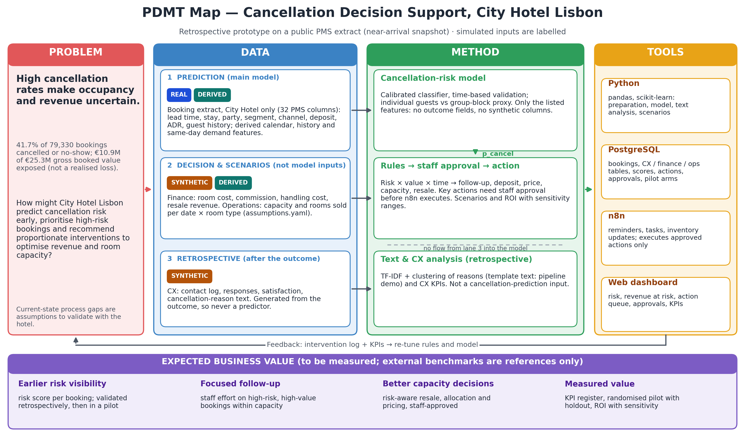

Detailed Expected Business Value
Baseline: City Hotel Lisbon, Jul 2015–Aug 2017 (41.7% cancellation rate). Targets without a sound benchmark will be set from model evaluation and baseline analysis. External benchmarks are pilot references from other settings.
Business function | Expected value and target | Evaluation and data
1. Cancellation risk prediction | Provisional goal: recall ≥ 70% on the 2017 test cohort of individual bookings, i.e. detect at least 70% of cancelled or no-show bookings, with the threshold chosen on validation folds to limit false alerts. | Recall, Precision, PR-AUC and Brier score vs. a baseline model on the 2017 arrival-cohort test set (a partially explored holdout: EDA looked at 2017 labels). Data: the feature lists in config/column_groups.json (e.g. lead_time, market_segment, distribution_channel, previous_cancellations; deposit_type for group blocks). booking_changes is excluded because it accumulates until check-in or cancellation.
2. Risk-based prioritisation | Focus resources on high-risk bookings: measure the actual cancellation rate in the top 20% by risk score. | Precision@20% and Lift@20% = Precision@20% ÷ event rate of the same evaluation cohort (e.g. 34.4% for the individual 2017 test cohort), not a fixed 41.7%. Data: model risk score, is_canceled. Formulas, owners and baselines: docs/kpi_register.csv.
3. Customer experience and retention | Pilot: act on the highest-risk bookings instead of broad contact. The threshold is chosen locally on validation folds from staff capacity, intervention cost and expected benefit. The 75% threshold from churn research on repeat customers (van Leeuwen et al., 2025) is a reference only, not an established cancellation threshold. | Retention uplift (pp) = stay rate of all bookings randomly assigned to treatment − stay rate of all bookings assigned to the holdout (intention to treat, whether or not contact succeeded); also response and cancellation rates. A randomised holdout is required for a causal claim. Data: pilot contact log with a randomised holdout and is_canceled (the simulated CX table cannot estimate uplift).
4. Finance and revenue recovery | Reference: in a numerical example with one hotel and two third-party websites, overbooking raised hotel profit by 4.20% (Dong & Ling, 2015, abstract); see also Pimentel et al. (2019). A model benchmark from another setting, not an expected gain for this hotel. | Net recovery on one contribution basis = resale revenue × (1 − commission) − room cost of resold nights + retained deposits − handling and intervention costs. The €10.9M gross figure is not net recovery. Staff-cost floor: Portugal minimum wage €505–557 per month, 2015–2017 (Hans-Böckler-Stiftung, n.d.).
5. Room inventory and operations | Reference (qualitative): updating booking limits over time under cancellation risk, rather than optimising once, improved contribution in a simulation study (Cha, 2026). The exact figure could not be verified and is not used as a target. | Resale rate = Rooms resold after cancellation ÷ Cancelled rooms eligible for resale; also unsold room-nights by arrival date. Compare operations with and without cancellation prioritisation.

References
Antonio, N., de Almeida, A., & Nunes, L. (2017). Predicting hotel booking cancellations to decrease uncertainty and increase revenue. Tourism & Management Studies, 13(2), 25–39. https://doi.org/10.18089/tms.2017.13203
Antonio, N., de Almeida, A., & Nunes, L. (2019a). Big data in hotel revenue management: Exploring cancellation drivers to gain insights into booking cancellation behavior. Cornell Hospitality Quarterly, 60(4), 298–319. https://doi.org/10.1177/1938965519851466
Antonio, N., de Almeida, A., & Nunes, L. (2019b). Hotel booking demand datasets. Data in Brief, 22, 41–49. https://doi.org/10.1016/j.dib.2018.11.126
Cha, J. (2026). Machine learning-driven overbooking optimization under dynamic cancellation risk: Evidence from hotel revenue management. Computers & Industrial Engineering. Advance online publication. https://doi.org/10.1016/j.cie.2026.112341
Dong, Y., & Ling, L. (2015). Hotel overbooking and cooperation with third-party websites. Sustainability, 7(9), 11696–11712. https://doi.org/10.3390/su70911696
Hans-Böckler-Stiftung. (n.d.). WSI minimum wage database: Portugal. https://www.boeckler.de/pdf/ta_portugal_mwdb.pdf
Iberian Property. (n.d.). Lisbon, Porto and the Algarve attract more hotel investors [JLL data]. https://iberian.property/news/archive/lisbon-porto-and-the-algarve-attract-more-hotel-investors/
Lusa. (2017, June 6). Em 2016, abriram em Portugal mais 81 empreendimentos turísticos [Deloitte Atlas da Hotelaria data]. ECO. https://eco.sapo.pt/2017/06/06/em-2016-abriram-em-portugal-mais-81-empreendimentos-turisticos/
Pimentel, V., Aizezikali, A., & Baker, T. (2019). Hotel revenue management: Benefits of simultaneous overbooking and allocation problem formulation in price optimization. Computers & Industrial Engineering, 137, Article 106073. https://doi.org/10.1016/j.cie.2019.106073
Talluri, K. T., & van Ryzin, G. J. (2004). The theory and practice of revenue management. Springer.
van Leeuwen, R., Do, H. D., & Koole, G. (2025). Churn management in hospitality. Journal of Big Data, 12, Article 145. https://doi.org/10.1186/s40537-025-01204-8

